I. INTRODUCTION
Autonomous Hydrographic Survey Vessel
Carter Ashby, Andrew Alley, Joshua Herrera, Levi Daniel

Bathymetry is the study and measurements of different bodies of water, such as lakes, rivers, oceans, etc. These analyses are crucial for determining the shape of the water body. Furthermore, data obtained from bathymetry can be used to monitor the effects of climate change, beach erosion, and subsidence. The Tennessee Tech Water Center also uses bathymetry to create simulations to predict natural disasters and locations that are more susceptible to flooding. The Water Center currently has boats that take bathymetric projections that are remote-controlled; however, this technology is prone to human error and lacks efficiency that could be further improved by automation. There are currently autonomous vehicles that take bathymetric measurements accurately and precisely, but these solutions are at a significantly higher budget than set by the Water Center.

A. Understanding This Paper
The point of this paper is to present the problem that this project is aiming to solve. The goal of this project is to develop an autonomous machine that measures the depth of bodies of water. These measurements will then be used to create an accurate bathymetry map of the lake, river or pond that is being mapped. The rest of this paper will describe the science and engineering behind this project and the process by which this project will be completed.

II. FORMULATING THE PROBLEM
In this section, the main objective of the project will be discussed as well as the specifications and constraints that make this objective worth working towards. The current solutions that are available will also be mentioned.

A. Background
The objective of this project is to create an autonomous, self-driving boat that will take water depth measurements of a body of water. These measurements will then be used to create bathymetry maps for bodies of water such as lakes, rivers, and ponds such as the map shown in Figure 1. Bathymetric data has many uses in scientific research. For example, bathymetry maps can be used for the prediction of flood inundation [1]. These maps can help water managers to calculate and perform simulations on how water would flow in possible scenarios such as flooding or broken dams [2]. This data can then be used to create potential evacuation routes and emergency protocols if these scenarios were to happen.

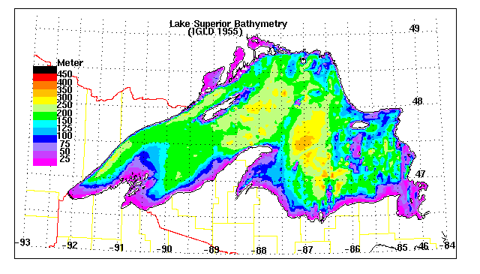
Figure 1: Bathymetry Map of Lake Superior

Boats or watercraft that are used to collect bathymetric data are known as hydrographic survey vessels (HSV). Bathymetric data is collected with HSVs using multiple techniques. This includes using a rod or weighted line that is placed in the water [3]. The line would be cast into the water to measure the depth and the coordinates of that measurement would be recorded. This process can take several days depending on the size of the body of water. Even then the number of data points that are recorded is often too low to produce a useful bathymetric map [4]. For lakes that are exceptionally deep, measuring rods become useless. The usefulness of this method depends on the navigability of the body of water as well since shallow waters make it difficult to use a full-size boat.
Another more efficient method is to use sonar technology. HSVs can be equipped with sonar sensors that are capable of measuring much further depths than a measuring rod [3, 4]. These HSVs also use a GPS to record the location that each measurement is made. The number of measurements that can be taken drastically increases as well [4]. These types of HSVs are rather large since they are commonly used for oceanic bathymetry as seen in Figure 2. This means that navigability is still an issue.

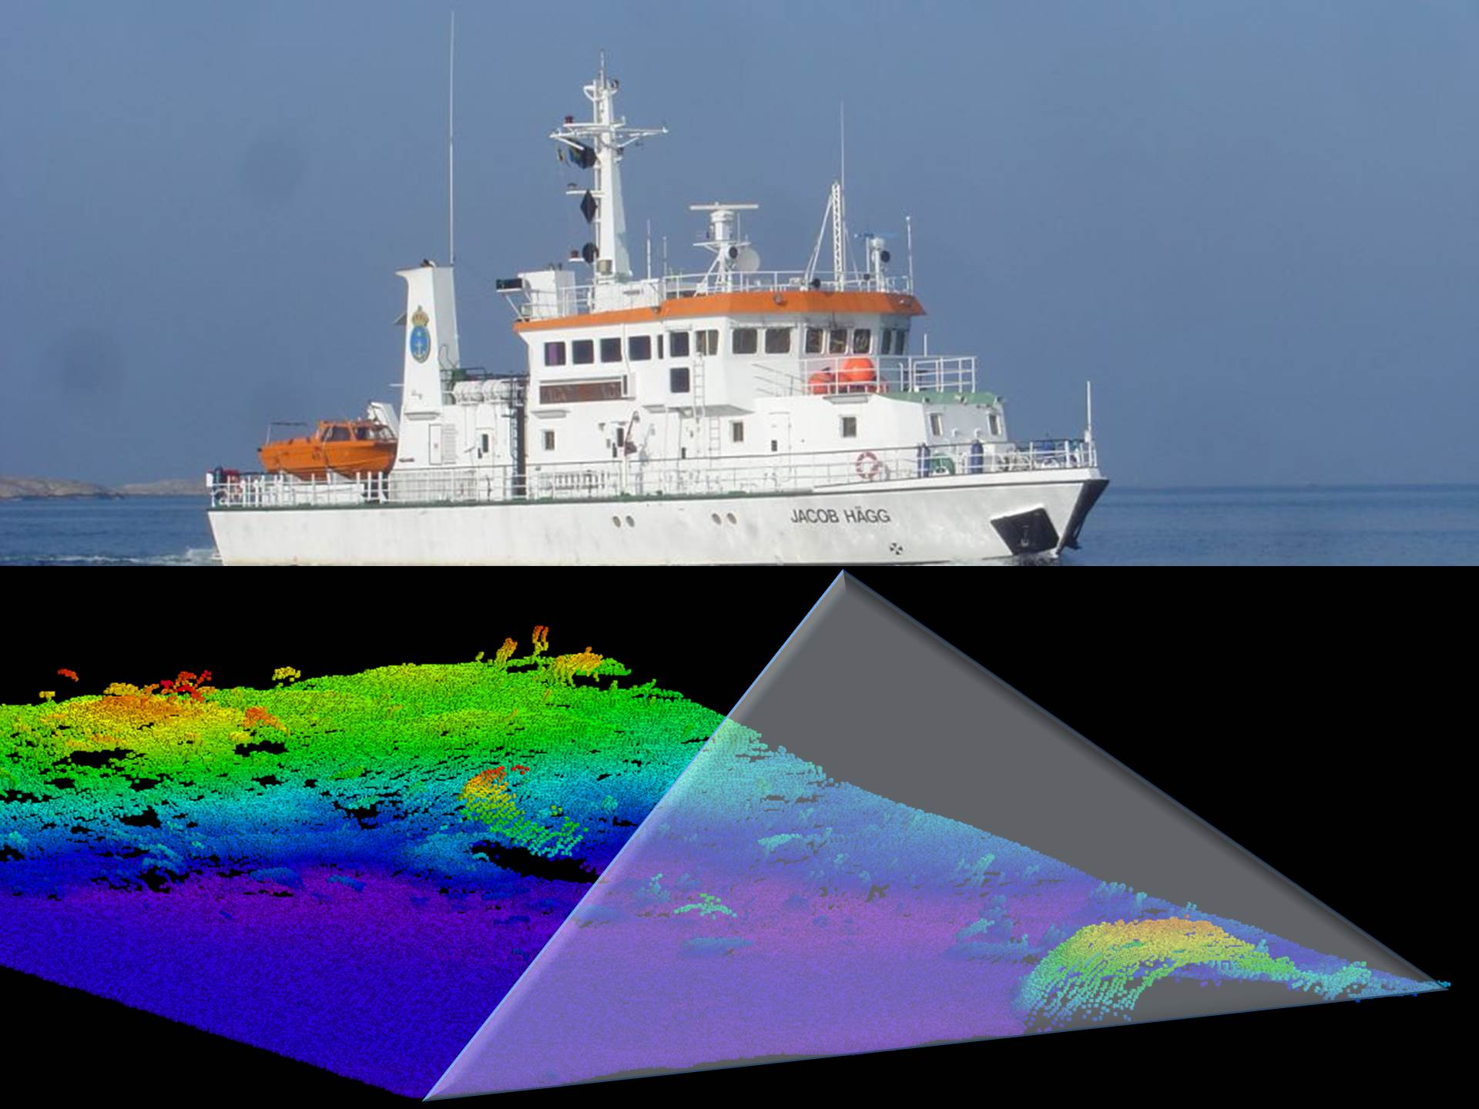
Figure 2: Oceanic Hydrographic Survey Vessel

There are remote controlled HSVs that are available for use as well. These are typically much smaller than a full-size boat since they are unmanned. However, since they are remote-controlled, there is still human error when collecting data measurements. The boats will often take multiple measurements of one spot due to a lack of precision from the person controlling the boat. Accurate measurements of bodies of water are then potentially skewed, which then requires the need for more data recording to be done. Doing so can become a waste of time and the boat’s battery life.
An automated boat, however, can be given a certain path without overlap and can ensure appropriate water depth measurements are taken without redundancy. While automated boats are available in the commercial market, the price for these boats can start at around $70,000. The project would have a significantly smaller budget if a team were to program the boat themselves. Furthermore, this would also make the software more accessible to organizations and/or communities who would be potentially interested in using an automated boat to improve safety protocols which can help reduce property damage and casualties.
Since there can still be errors that are not detected by the HSV, there should be an operator observing the data collection at all times. To make sure that the data is accurate, it will be streamed in real-time to a tablet. This will minimize the amount of error that is made when collecting the bathymetric data of the body of water.

B. Specifications
The size of the boat must be small enough that one or two people can lift and carry it for use and storage. The boat must be large enough that it can maneuver easily in the water without being influenced too much by water current or wind and without being too slow or cumbersome.
The boat must be able to support enough weight that the control circuits, communication electronics and sensors can all fit into the boat without issue.
The boat must be able to travel at a fast enough speed for normal travel around the water body, but also able to travel slow enough during data collection to allow for minute adjustments for each data point.
The battery life for the motors and sensors must be long enough to complete small water bodies without needing to stop and recharge. In conjunction with data collection speed, the boat will need to have a long enough battery life and a fast enough data collection that a water body such as Cane Creek Lake can be captured in one attempt.
The boat must be able to send a live feed of data to the on-site technician for monitoring. There must also be an abort collection option available to the technician, in case the data being collected does not seem suitable in real-time.
The boat must be able to withstand slight weather problems, such as light rain or wind. The boat will not be in operation when weather is severe, but the technician is not required to be “comfortable.”
The construction, assembly, and parts of the boat must be cheaper altogether than commercially available options.
In order to communicate wirelessly with the on-site technician, the boat will use either Wi-Fi or radio signals, which are regulated by certain government standards.

C. Constraints
The minimum size of the boat must be 3 feet long and 2 feet wide. The maximum size of the boat must be 5 feet long and 3 feet wide.
The boat must be able to handle a payload between 10 and 20 pounds, including control hardware and sensors.
The boat must collect data at speeds between 1 and 3 feet per second.
The battery life of the boat must be at least 1 hour.
A water body with an area of roughly 2 million square feet must be able to be completed in one attempt.
The regulations that govern remote control radio signals require that the boat only be controlled via radio signals in the 26-28 MHz band and that power output from the transmitter be no more than 4 Watts. The radio signals used to control the boat must also only control the boat; they cannot be used to transmit data from the collection process [5].
The regulations that govern Wi-Fi signals require that Wi-Fi frequencies be restricted to 902-928 MHz, 2400-2483.5 MHz, or 5725 to 5875 MHz, as they are considered unlicensed wireless equipment devices [6]. The transmitter is also required not to exceed a peak output power of 1 Watt, and the Effective Isotropic Radiated Power (EIRP) cannot exceed 4 Watts [7]. The EIRP is simply a combination of the output power and the antenna gain.

D. Survey of Solutions
As mentioned previously, one of the solutions to this problem is to take manual depth measurements of a lake using a rod. Although this will produce accurate depth measurements, it cannot create an accurate image of a lakebed. In order to produce a higher resolution bathymetry map, more data points are needed [4].
Another solution is using a sonar sensor attached to the bottom of a boat. Single beam and multi-beam echo sounding are used to create high resolution bathymetry maps [8]. The problem with this solution is the cost. One commercially available item includes the CEE-USV from CEE HydroSystems shown in Figure 3 [9]. This product is capable of taking manual or autonomous hydrographic surveys of shallow bodies of water [9]. However, this product is not easily accessible and is very costly.
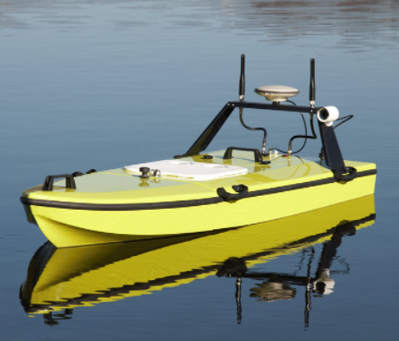

Figure 3: CEE-USV

E. Summarizing the Problem
Bathymetry maps for shallow bodies of water are inefficiently produced and poorly made. The data that is collected from using techniques such as measuring the depth with a rod is insufficient in producing data that is useful for scientific study. The use of sonar technology can significantly reduce the time and manual labor of bathymetric measuring. However, shallow bodies of water are difficult to navigate with full-size boats. Remote-control options are available but are more susceptible to human error. Autonomous options are available but they are usually very costly and are only provided as a service.
The goal of this project is to create a low-cost autonomous hydrographic survey vessel that is capable of taking accurate depth measurements in shallow bodies of water. However, for this product to be useful, the specifications and constraints that were provided by the TN Tech Water Center must be met as well. This includes limitations on the size of vessel for portability. The HSV must also be autonomous and have a battery that lasts long enough so that it does not lose power in the middle of a lake. This project must also comply with regulations regarding Wi-Fi signals since it will stream data in real-time to a tablet.

III. CREATING A SOLUTION
This section will discuss how this capstone group will go about creating a solution to this problem while meeting the given specifications and constraints.
After evaluating the given specifications and constraints, it is possible to begin devising the path forward to the final product. The requirement to deliver a boat that will navigate the entirety of a body of water without direct control from the user will be met by constructing a watercraft driven by software that intelligently plots and follows a course that will allow the boat to collect measurements over the full area of the body of water. To collect the required bathymetry data samples the boat will be equipped with sonar and GPS. A sonar sensor is the most likely solution for depth measurement device since that is what was specifically mentioned by the Water Center. An accurate GPS-generated location reading will be recorded with each sonar measurement, and data processing software will be used to generate maps and charts from the collected data. A software application will also be developed that will allow someone onsite to transmit commands to the boat while also being able to view the collected bathymetry data in real time.

A. Unknowns
Some of the given specifications will require experimentation and analysis in order to make precise design decisions. For example, to calculate the distance the boat will be able to travel on a single charge of the battery, it will be necessary to analyze factors such as the resistance the water will have on the boat’s hull, the effects of a moving current, and the power needed by the motor to maneuver the boat through the water. It will be possible to better predict and estimate the effects of these factors when the boat’s dimensions and weight are determined. Next, further investigation of the depth data collection method will need to be done to determine how accurate the GPS system needs to be. This will depend on the distance between depth measurements and the sonar sensor’s area of coverage. Finally, the specification that the product should be able to handle “mild weather” will need to be quantified. This could be done by simulating and measuring the effects of average winds and light rain on the boat.

B. Measures of Success
In order to verify that each specification and constraint has been satisfied, methods of validation will be determined. The necessary experiments, simulations, and analysis will also be detailed. With regard to the low cost specification, proposed solution costs will be evaluated by the customer and will be adjusted or adhered to based on the given feedback. The size of the boat and its payload capacity will be confirmed to meet the constraints when the other components are selected and the boat is constructed. This specification will be kept in mind as the onboard components are selected and designed. The durability of the boat will be determined by the research done on the materials used and the analysis of potential designs. Durability will be validated by field testing with already existing designs or by testing the product directly. The given accuracy constraints for the sonar sensor and the GPS will be confirmed by comparing their collected data to manually collected truth data samples. This truth data will be collected using maps for true GPS locations and existing manual water depth measurement methods. The software requirements for a real-time test observation application and a complex bathymetry mapping software will be validated by processing simulated data, executing abbreviated tests, and by through multitude of test iterations. The analysis of the results produced by the software will determine when the specifications are met. Finally, the methods for verifying the constraints regarding the battery life, mobility, and speed of the boat will include simulating and predicting how the boat will behave in the water with the selected hull design, motor(s), and battery. In addition, individualized component tests and abbreviated full prototype tests will help model the capabilities of the product. The designs will be validated with many test iterations and demonstrations.

C. Broader Implications
When designing and constructing this automated boat, it is crucial that the team must observe the potential effects the boat may have on wildlife and ecosystems. Component materials must be taken into consideration to minimize these risks. Quality of batteries will need to be optimized to ensure that lithium does not leak into the bodies of water, killing marine life in the process. Furthermore, motor speeds must be fast enough to take measurements but not too fast as to disturb any wildlife or even people. Autonomous vehicles are still new in the engineering field and still pose issues when detecting people and preventing any injuries and/or casualties.
Another issue to take into consideration with the construction of the automated boat is the costs of production. The Water Center has emphasized the importance of creating a low-budget autonomous boat that other communities could recreate this project to help potentially decrease property damage and save lives.

IV RESOURCES
This section will discuss what we have available in terms of money, personnel, and our proposed timeline. The necessary physical resources and budget will be supplied and regulated by the TN Tech Water Center.

A. Personnel
When creating a piece of automated machinery, it is crucial that teammates be proficient in programming and debugging software. Levi Daniel excels in programming languages such as Python, C, and C++, and Carter Ashby is proficient in C++. Controlling the boat will require a form of wireless communication, whether this communication is through Wi-Fi or radio waves. Joshua Herrera possesses the skill of working with signal processing and wireless communications. Construction of the boat will also be important, for a circuit that is safe and durable is imperative when performing on water. Andrew Alley excels in circuit construction and hardware regarding component values, soldering, etc.
One skillset that is necessary that the teams lacks that the project will require is 3D printing. This will be used to create the hull of the boat for the machinery to be placed on. Some schematics and hulls are readily available that are provided by Tennessee Tech Water Center. Furthermore, Dr. Kalyanapu has offered to aid in modifying hull designs if the machinery is too large or cumbersome. Another scope of the project the team is unfamiliar with is the use and implementation of sonar equipment. Dr. Kalyanapyu will also help the team with picking sonar devices and provide previously used boats to present how the equipment is used.

E. Timeline

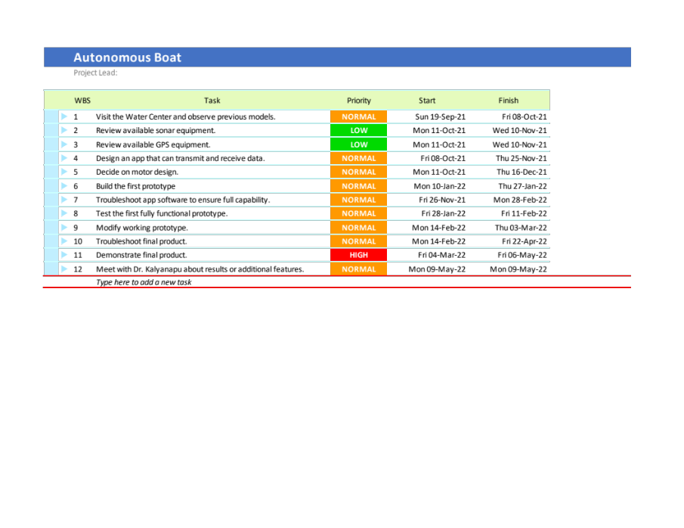

REFERENCES
[1] N. A. Adnan and P. M. Atkinson, "Remote sensing of river bathymetry for use in hydraulic model prediction of flood inundation," 2012 IEEE 8th International Colloquium on Signal Processing and its Applications, 2012, pp. 159-163, doi: 10.1109/CSPA.2012.6194710.

[2] F. Bandini, D. Olesen, J. Jakobsen, C. M. M. Kittel, S. Wang, M. Garcia, and P. Bauer-Gottwein, “Technical note: Bathymetry observations of inland water bodies using a Tethered SINGLE-BEAM SONAR controlled by an unmanned aerial vehicle,” Hydrology and Earth System Sciences, 07-Aug-2018. [Online]. Available: https://hess.copernicus.org/articles/22/4165/2018/. [Accessed: 10-Sep-2021].

[3] “How are bathymetric maps made?,” Ausable River Association. [Online]. Available: https://www.ausableriver.org/blog/how-are-bathymetric-maps-made. [Accessed: 10-Sep-2021].

[4] S. Shelke, S. Balan and C. Kumar, "Analysis of bathymetry data for calculating volume of water in a reservoir," 2016 Conference on Advances in Signal Processing (CASP), 2016, pp. 83-87, doi: 10.1109/CASP.2016.7746142.

[5] Code of Federal Regulations: Title 47, Part 95, Subpart C, https://www.ecfr.gov/current/title-47/chapter-I/subchapter-D/part-95/subpart-C

[6] Code of Federal Regulations: Title 47, Part 18, Subpart C https://www.ecfr.gov/current/title-47/chapter-I/subchapter-A/part-18/subpart-C

[7] Code of Federal Regulations: Title 47, Part 15, Subpart C https://www.ecfr.gov/current/title-47/chapter-I/subchapter-A/part-15/subpart-C

[8] A. McDonald, “Hydrographic Surveying in Industrial Environments with Single Beam Bathymetric Echo Sounders and Unmanned Vessels.”. Available: https://www.ceehydrosystems.com/wp-content/uploads/2017/11/CEE_VIEWS_Industrial_Water_Surveying_and_USV_Applications.pdf

[9] “CEE-USV,” CEE Hydrosystems. [Online]. Available: https://ceehydrosystems.com/products/unmanned-survey-vessels/cee-usv/. [Accessed: 20-Sep-2021].

